NEPAL COLLEGE OF INFORMATION TECHNOLOGY
Balkumari, Lalitpur
Affiliated to Pokhara University

LAB REPORT FOR DATABASE MANAGEMENT SYSTEM


LAB REPORT 1: INTRODUCTION TO SQL

Submitted by: Submitted to:
Name: Arpan Adhikari Er. Simanta Kasaju
Roll No.: 231309
BE-CE (3rd SEM)

S. N | LAB TOPIC | DATE | REMARKS
1. | INTRODUCTION TO SQL | 10th Nov

LAB 1: INTRODUCTION TO SQL

OBJECTIVE:
The purpose of this lab is to familiarize students with SQL (Structured Query Language) fundamentals, particularly within the environment of relational Database Management Systems (DBMS). Students will explore SQL commands related to database creation, data insertion, and data retrieval. This lab emphasizes building a solid foundation in SQL syntax, using commands like CREATE, INSERT, SELECT, and exploring basic data types and constraints.

THEORY:
SQL, or Structured Query Language, is the standard language used for accessing and manipulating data within relational databases. It allows users to perform tasks such as data insertion, querying, updating, and deleting. SQL operates through a variety of DBMS platforms, including MySQL, PostgreSQL, Oracle, and SQL Server.
Key SQL Commands in Different Categories:
- Data Definition Language (DDL):
  - CREATE: Creates database structures, such as tables or views.
  - ALTER: Modifies the structure of an existing table.
  - DROP: Deletes a table or other database objects.
- Data Manipulation Language (DML):
  - INSERT: Adds new data to a table.
  - UPDATE: Changes existing data within a table.
  - DELETE: Removes data from a table.
- Data Query Language (DQL):
  - SELECT: Retrieves data based on specified criteria.
- Data Control Language (DCL):
  - GRANT: Grants permissions to users.
  - REVOKE: Removes permissions from users.
- Transaction Control Language (TCL):
  - COMMIT: Saves all changes made in the current transaction.
  - ROLLBACK: Reverses changes made within a transaction.

Common SQL Data Types:
- Numeric Types:
  - INT: Integer values.
  - DECIMAL: Fixed-point numbers with a specified precision.
- Character Strings:
  - CHAR(n): Fixed-length character string.
  - VARCHAR(n): Variable-length character string.
- Date and Time:
  - DATE: Represents a date.
  - DATETIME: Represents both date and time.
- Boolean Type:
  - BOOLEAN: True or false values.
- Binary Types:
  - BLOB: Stores large binary data, such as files or images.

Steps to Execute SQL Commands:
- Install XAMPP:
  - Download and install XAMPP, which provides an Apache server, MySQL, and PHP for database management.

- Launch phpMyAdmin:
  - Start the XAMPP control panel and launch phpMyAdmin through http://localhost/phpmyadmin.
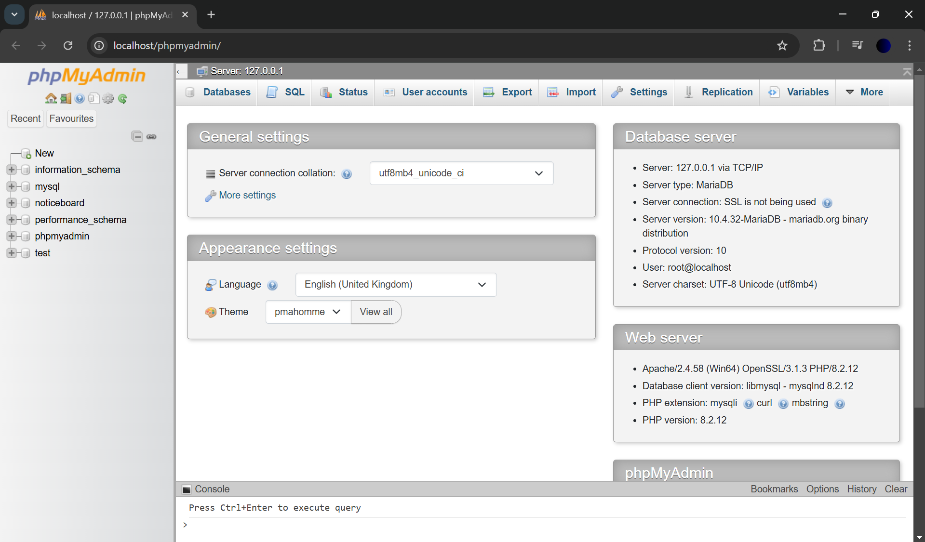

- Create Database and Tables:
  - Within phpMyAdmin, create a new database and define table structures using CREATE TABLE commands or through the interface.

- Run SQL Statements:
  - Use the SQL tab in phpMyAdmin to write and execute SQL commands like INSERT and SELECT.

- View Results:
  - After executing commands, check the output to verify that data was inserted, updated, or retrieved correctly.

Questions:
Create a new database named with your first name and a new table with your last name. The
table should have the following columns: id, name, gender, address, dob, phone, qualification,
relation, age, and vote. Additionally, display the following information:
1. Individuals who are capable of voting.
2. Individuals with an age greater than 32.
3. Individuals with a gender of male.
4. Individuals from Kathmandu with a male gender.
5. Male individuals with an age less than 30.
6. Individuals who have completed a master's degree, with an age between 30 and 50, and
are male.
7. Individuals whose relation is either sister or friend.

Answer:

Creating new database and table:

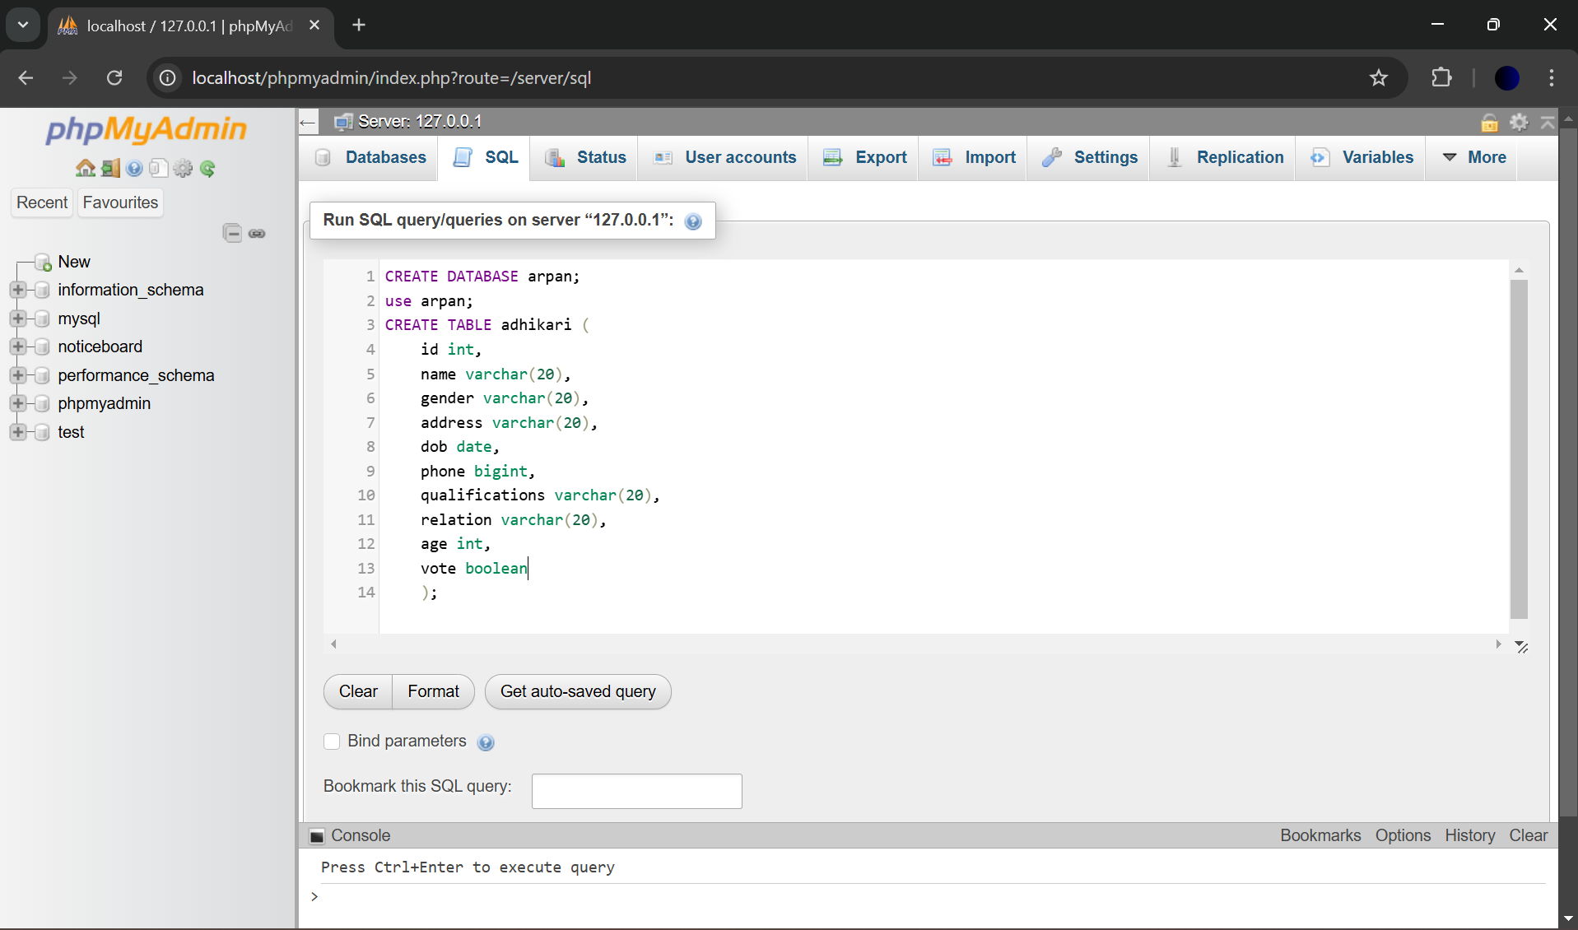

Inserting data into table:

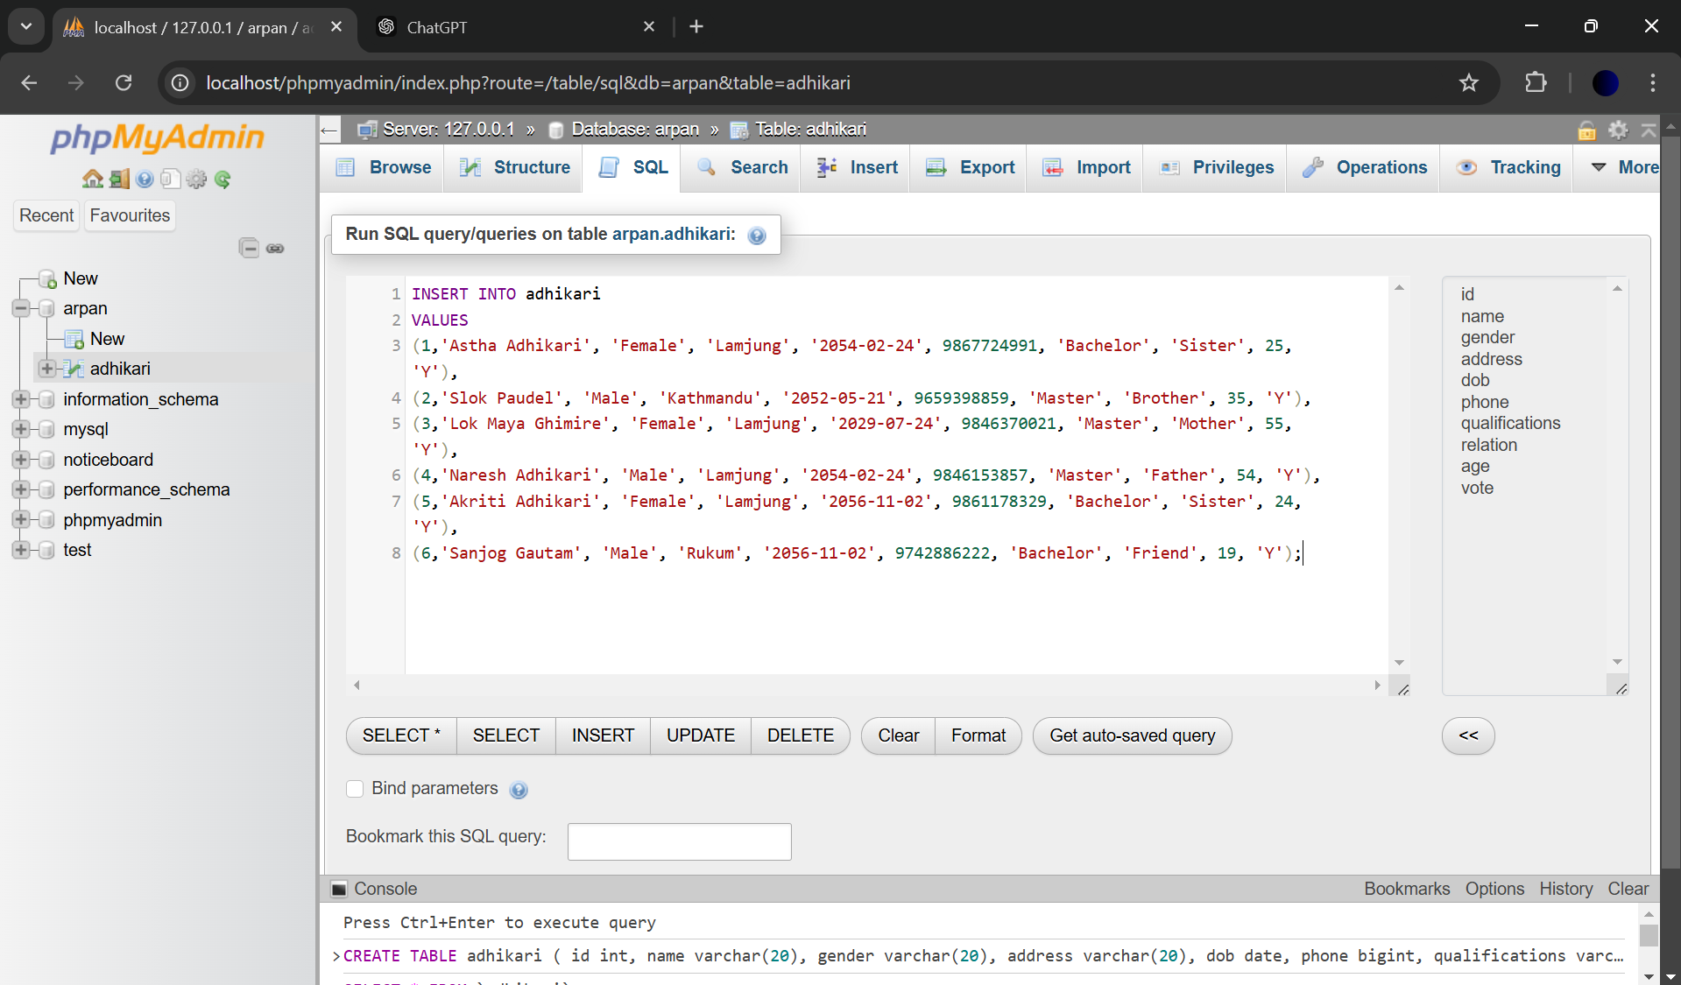

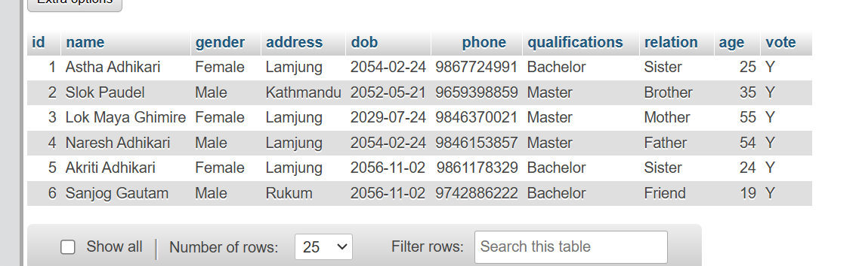

Queries:

- Individuals who are capable of voting.
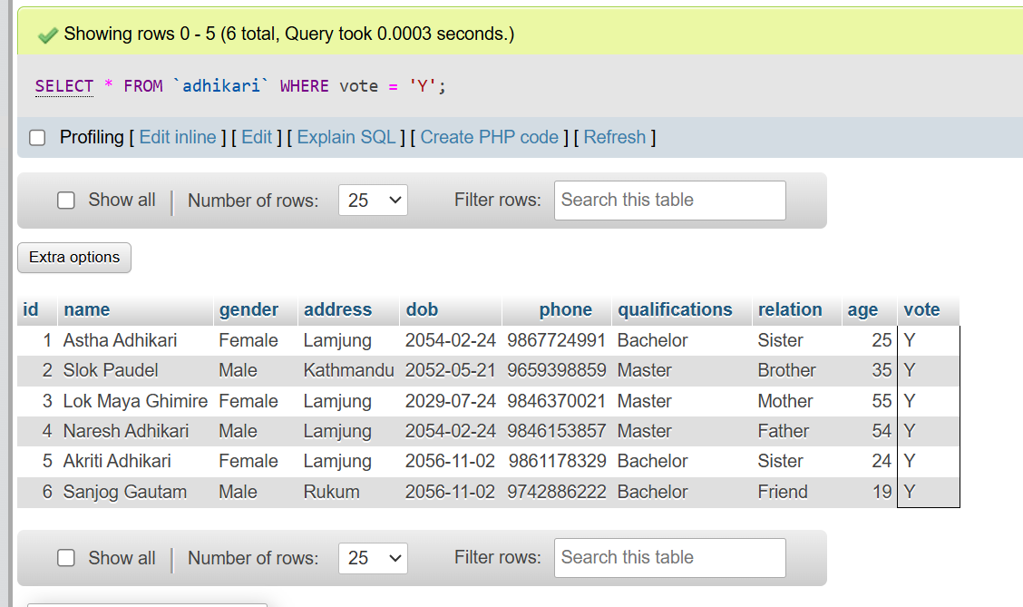

- Individuals with an age greater than 32.
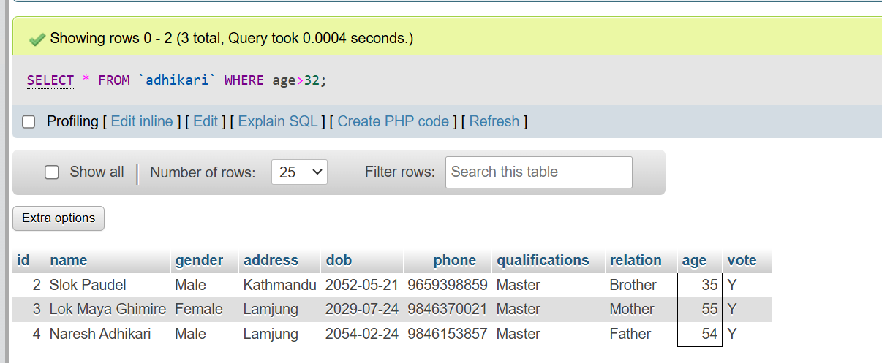

- Individuals with a gender of male.
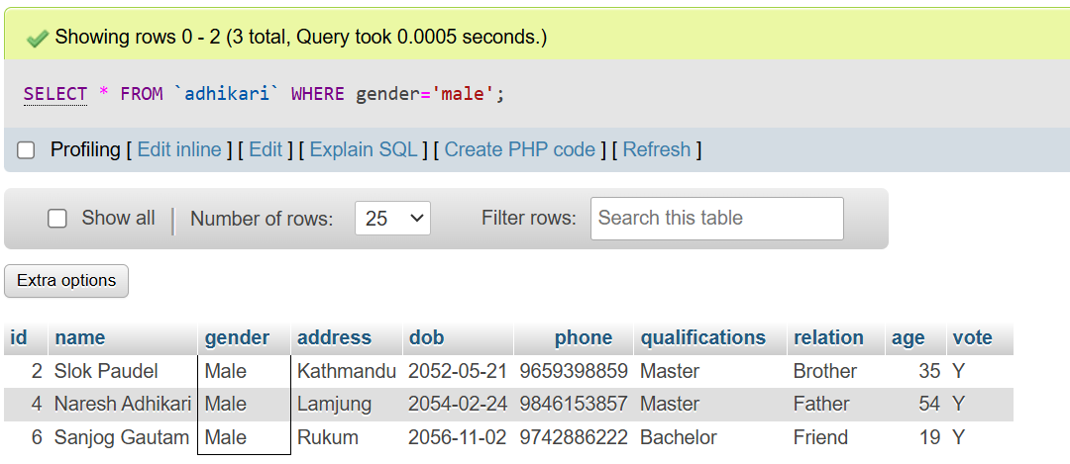

- Individuals from Kathmandu with a male gender.
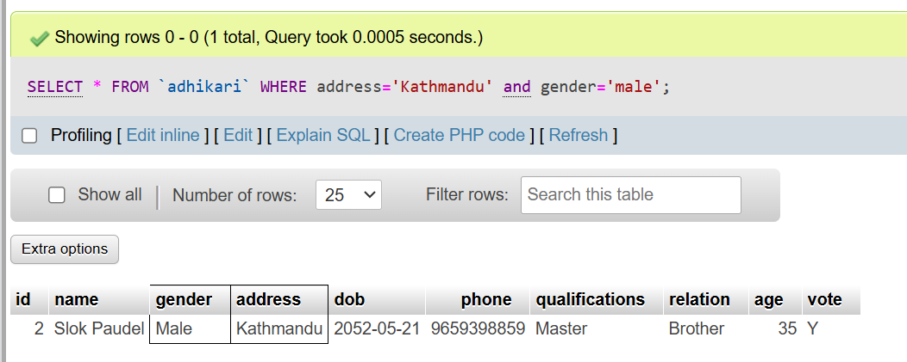

- Male individuals with an age less than 30.
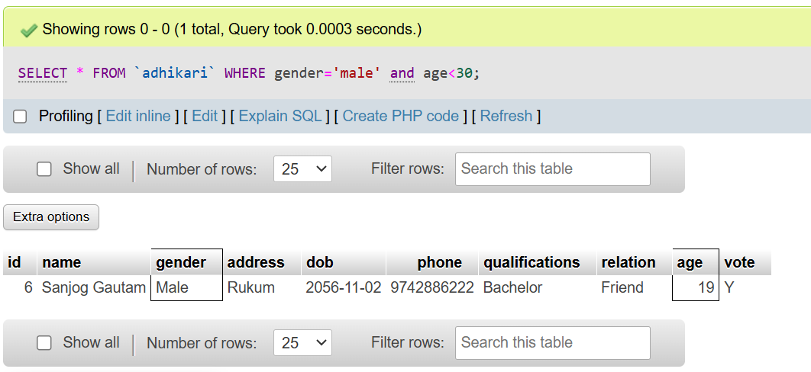

6. Individuals who have completed a master's degree, with an age between 30 and 50, and
are male.

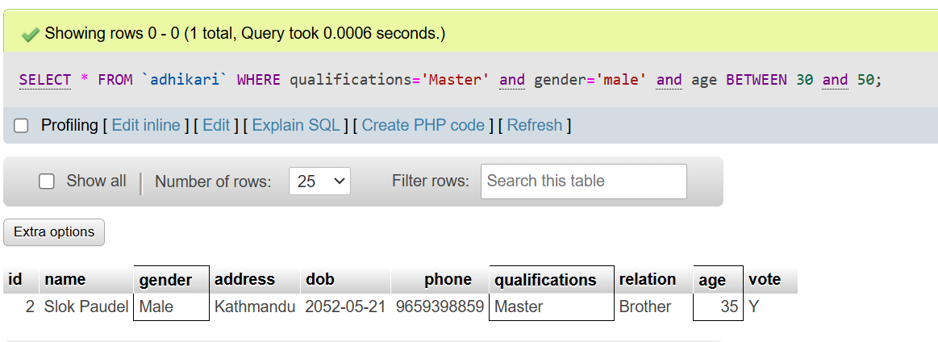

7.Individuals whose relation is either sister or friend.

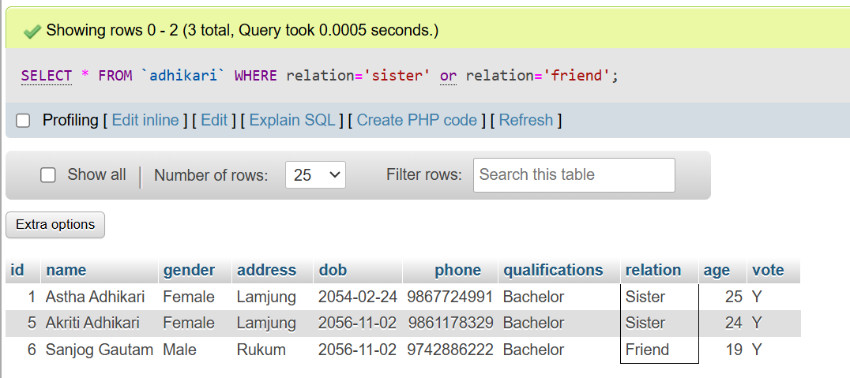

CONCLUSION:

In this lab project, I gained practical experience with SQL fundamentals, including database and table creation, as well as running complex queries to filter data based on specific conditions. By designing a database with essential fields and querying it to retrieve targeted information, I strengthened my understanding of SQL commands such as `SELECT`, `WHERE`, and conditional filtering. This exercise not only enhanced my technical skills but also helped me understand how to structure data effectively for real-world applications, enabling efficient data management and retrieval.

